Discrete Math
By:

Julie Cook, Park Rapids Century Middle School, jcook2@parkrapids.k12.mn.us

Gabe Sturtz, Park Rapids Century Middle School, gsturtz@parkrapids.k12.mn.us

6th Grade Unit

Executive summary

In this project, students will be able to use tables, and tree diagrams as they learn about sample space. They will be able to manipulate items to discover various combinations. Students will explore multiple voting methods to see the advantages and disadvantages of each system for voting. In addition they will explore paths and circuits, as well as weighted graphs and the multiple methods to find solutions. They will be given time to explore each of these representations with their peers and share their thinking, which will guide them to deeper understanding.

In the unit involving voting methods, students will receive opportunities to analyze data. The unit leads off with an engaging vote for the students to partake, and leads them to evaluating the outcome in several different methods. This also gives students the chance to expand on their knowledge of sample space in a real world application.

Included in this unit are graphs and maps which will be a great way for students who struggle with computational math to use their skills to problem solve. Students will receive numerous opportunities to collaborate with one another to plot points, graph distances, and estimate and calculate perimeter.

MN Math Standard(s):
6.1.1.1 Plot pairs of positive rational numbers on a coordinate grid.

6.1.3.4 Solve real-world and mathematical problems requiring arithmetic with decimals, fractions and mixed numbers.

6.3.1.3 Estimate the perimeter and area of irregular figures on a grid when they cannot be decomposed into common figures and use correct units, such as cm and cm2.

6.4.1.1 – Determine the sample space (set of possible outcomes) for a given experiment and determine which members of the sample space are related to certain events. Sample space may be determined by the use of tree diagrams, tables or pictorial representations.

Sample MCA question

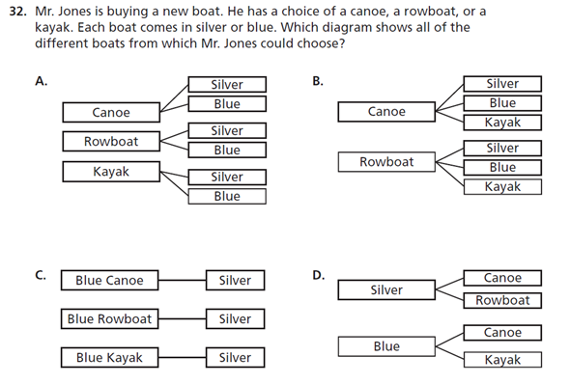

Table of Contents

Pre-test 4 – 6
Unit 1
Sample Space Using a Table 7 – 8
Sample Space Using a Tree Diagram 9 – 11
Target Combinations 12 – 14
Permutations - Making a List 15 – 16
Permutations - Using Multiplication 17 – 18
Unit 2
Voting: Popularity and Elimination 19
Borda Voting System 20
Head-to-Head Voting System 21
Unit 3
Intro to Maps and Graphs 22 – 23
Euler Paths and Circuits 24
Hamilton Paths and Circuits 25
Weighted Edge Graphs 26
Greedy Algorithm and Nearest Neighbor 27
Unit 4
Organizing Attributes with Venn Diagrams 28 – 30
Using Venn Diagrams with Three Circles 31 – 33

Post-test 34 – 37

Name: ________________________________________________ Date: __________

Discrete Mathematics Pre-Test

- Evan has three sweatshirts (a green one, a yellow one, and an orange) and three pairs of pants (jeans, khaki pants, & black pants). Create a table to represent the possible outfits.
How many different outfits are there? ________

- At a restaurant, Mark can choose a choice of meat, potato, and beverage. For meat, he can choose chicken or steak. He can choose mashed potatoes, a baked potato, or French fries. He can choose soda or milk. Create a tree diagram to represent the possibilities. Be sure to list the outcomes.
How many possibilities are there? __________________

- In the Battle of the Bands contest, in how many ways can the four participating bands be ordered? Make a list to show your arrangements.

- In how many ways can a family of five arrange themselves in a line for a family portrait?

- Use the data provided from a vote to decide who the winner would be using the Popularity Method, Elimination Method, Borda Method, and Head to Head Method.

Ms. Gustafson’s class took a vote for which candy to get for the movie they were watching. They had 3 choices: Kit-Kat, Reese’s Peanut butter Cups, or MMs. The students were told to put them in a list from favorite to least favorite. Here are their results:

Kit-Kat, Reese’s Peanut Butter Cups, MMs | 3
Kit-Kat, MMs, Reese’s Peanut Butter Cups | 3
Reese’s Peanut Butter Cup, MMs, Kit-Kat | 8
Reese’s Peanut Butter Cup, Kit-Kat, MMs | 10
MMs, Reese’s Peanut Butter Cup, Kit-Kat | 3
MMs, Kit-Kat, Reese’s Peanut Butter Cup | 1

Which won using the Popularity method? _____________________________________
Which won using the Elimination method? ____________________________________
Which won using the Borda method? _______________________________________
Which won using the Head to Head method? _________________________________

- Decide if this graph can be used to create an Euler path, Euler circuit, Hamiltonian path, or Hamiltonian circuit.

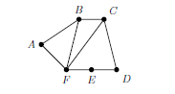

Euler path? ____________ If yes, tell the path: ______________________________________________________________________
Euler Circuit? ____________ If yes, tell the circuit: ______________________________________________________________________
Hamiltonian path? ____________ If yes, tell the path: ______________________________________________________________________
Hamiltonian circuit? ____________ If yes, tell the circuit: ______________________________________________________________________
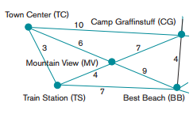
7.

Use the diagram to decide the shortest path possible to start at any location and end at that same location. Do the same thing using the Greedy method and Nearest Neighbor method.

Shortest Path Possible: _____ → _____ → _____ → _____ → _____ = __________

Greedy Method: _____ → _____ → _____ → _____ → _____ = __________

Nearest Neighbor: _____ → _____ → _____ → _____ → _____ = __________

8. Solve the following using a Venn diagram.
In a class of 50 students, 18 take Chorus, 26 take Band, and 2 take both Chorus and Band. How many students in the class are not enrolled in either Chorus or Band?

9. Solve the following using a Venn diagram.
A veterinarian surveys 26 of his patrons. He discovers that 14 have dogs, 10 have cats, and 5 have fish. Four have dogs and cats, 3 have dogs and fish, and one has a cat and fish. If no one has all three kinds of pets, how many patrons have none of these pets?

Sample Space - Using a Table

Objective: 6.4.1.1 – Determine the sample space (set of possible outcomes) for a given experiment and determine which members of the sample space are related to certain events. Sample space may be determined by the use of tree diagrams, tables or pictorial representations.

Launch: Pose the problem: Suppose I have a red shirt and a blue shirt, jeans, black pants and khaki pants, how many combinations can be made with one shirt and one pair of pants?

Explore: Have students work in groups to determine a list of possible combinations. Walk around room and encourage students to be thinking about all the total possibilities. If students complete this part early extend the problem to include a pair of sandals, flip flops, and sneakers. How many total combinations can be made wearing a shirt, pair of pants, and one pair of shoes?

Share: Have students come to the front board to make a list of those possible combinations of the shirt and pants combination. Discuss the findings with the class. Allow the groups that were able to finish the extension to share their findings with the class.

Summarize: Discuss with students how just two pairs of shirts and 3 pairs of pants can create 6 possible combinations. Discuss how this is called a sample space. Have students imagine how many possible combinations they have in their dressers and closets with shirts, bottoms, socks, shoes, accessories, etc. Discuss with students about the possibility of having to make a list of the total combinations possible.

Assignment: Have students complete Sample Space Worksheet

Name: _________________________________________________ Date: __________

Sample Space Worksheet

- For breakfast, Jill can choose from the following cereals: Cereal, Cheerios, or Kix. She can also choose to have a muffin, toast, or a doughnut with her cereal. How many possible choices does Jill have for breakfast?

- After dinner, Lee can choose a dessert (either a cookie, an ice cream cone, or a brownie). He can also have either a juice box or milk. How many options does Lee have?

Sample Space - Using a Tree Diagram

Objective: 6.4.1.1 – Determine the sample space (set of possible outcomes) for a given experiment and determine which members of the sample space are related to certain events. Sample space may be determined by the use of tree diagrams, tables or pictorial representations.

Launch: Remind the students about the problem posed yesterday with the total combinations of shirts and pants, and then the addition of shoes for those groups that finished early. Discuss the need for careful organization when creating lists to make sure we don’t forget any combinations. Pose a new problem. Suppose we biked to Dorset for ice cream cones. The ice cream cones come in four sizes, kiddie, one scoop, two scoop, and three scoop. You also get the choice of sugar cone, cake cone, and waffle cone. For the ice cream let’s suppose that they only had 5 flavors available, s’more, peanut butter swirl, chocolate crunch, strawberries and cream, and white chocolate raspberry. How can we come up with a sample space without having to rely on listing them out to make sure we don’t forget any combinations?

Explore: Allow students to work together to come up with a way to determine the sample space for the ice cream problem. Walk around and guide students towards using a tree diagram.

Share: Have a group come to the front of the room to share their work and sample space.

Summarize: Discuss with students how a tree diagram can be a useful tool to help make sure that all possible combinations are being used. The tree diagram organizes the data into a neat list to be put together by the students to create a sample space.

Assignment: Have students complete the Sample Space - Tree Diagrams worksheet.

Name: ______________________________________________ Date: __________

Sample Space - Tree Diagrams Worksheet

Draw a tree diagram for each of the following situations. Remember to list your outcomes!

1. At the Panther Cafe, the dinner special is offered for $6.75. Customers may choose a meat choice (either a hamburger, hot dog, or cheeseburger) and a side choice (either French Fries or salad). How many meal options does Delilah’s Diner offer?

2. Each student at Century Middle School is going to donate a school supply (either a box of pencils, a box of crayons, or a box of markers) and a toy (either a baseball, a board game, or a doll).

3. At the end of a community race, runners can choose a bracelet (red, yellow, or green) and either a ribbon, medal, or certificate. How many choices do the runners have?

4. Create your own problem. Include your tree diagram and solution.

Target Combinations

Objective: Students should be able to create list of possible combinations. 6.4.1.1 – Determine the sample space (set of possible outcomes) for a given experiment and determine which members of the sample space are related to certain events. Sample space may be determined by the use of tree diagrams, tables or pictorial representations.

Launch: Give students the numbers 2, 3, 4, 5, 6, 7, 8 and have them come up with as many ways as they can to write the sum of 9. Have students share possible combinations. Discuss how we can use different combinations of numbers to get the same sum.

Explore: Have students get into 5-6 groups (depending on class size) and have them spread out around the room with each group going to a different target. Have the groups take 5 cotton balls. Have quick discussion about how these cotton balls are not intended to be thrown at people or things other than the target that belongs to their group. Students are to throw the 5 cotton balls at the board and record what numbers their tape balls landed on. Using only addition the students need to combine the numbers to create a score that is on their group worksheet. It is okay to have multiple different solutions to each score, but try to find at least one solution for each score. Continue doing this, rotating group members, until the teacher tells you time is up.

Share: Have students come together and write their solutions on the front board under each of the score numbers. If the same one is already written do not write it again, however it is okay to have multiple different solutions under individual numbers.

Summarize: Discuss how there are many different ways to write scores using only the 6 numbers given. Discuss how not all groups got the same score in the exact same order.

Target:

5
4
3
1
2
-3

Names: ______________________________________________ Date: ___________

Each group member needs to throw 5 cotton balls at the target. Record the points you get in the order that you tossed them. Find the total score and list the five point values under the score. It is okay to have multiple different solutions to each score, but try to find at least one solution for each score. Rotate through your group as many times as you can until the teacher tells you time is up.

List the combinations of the five throws to get each score below.

18 16 12 -6 10

__________ ___________ __________ __________ ___________
__________ ___________ __________ __________ ___________

19 7 22 21 0

__________ ___________ __________ __________ ___________
__________ ___________ __________ __________ ___________

2 3 4 5 6

__________ ___________ __________ __________ ___________
__________ ___________ __________ __________ ___________

Permutations - Making a List

Objective: Students will be able to determine how many ways to organize items when order matters. 6.4.1.1 – Determine the sample space (set of possible outcomes) for a given experiment and determine which members of the sample space are related to certain events. Sample space may be determined by the use of tree diagrams, tables or pictorial representations.

Launch: Pose the question: Suppose three students need to give presentations. The task is to find out how many different orders they can give their presentation. Pick three students to stand in the front of the class to demonstrate. Have the class record the different ways they get in order, 1st, 2nd, and 3rd. Once student think they have found all the different orders, discuss a way to make an organized list of all the unique orders.
Discuss the word permutation and have the students talk about the importance of how order matters.

Explore: Using modeling, set three balls; football, soccer ball and volleyball; in the front of the room and have students create a list to determine how many different ways we can arrange them. Walk around the room, when students finish ask them to include a tennis ball and determine the different ways to arrange them.

Share: Have students share their solutions with the large group. Discuss with students how they found their solutions. Have students explain the importance of why order matters.

Summarize: Together review the importance of why order matters. Answer any questions that arise and help clear up and confusion students may have.

Assignment: Permutations - Making a List worksheet

Name: _______________________________________________ Date: _________

Permutations - Making a List

Make a list to determine the total number of ways the following things can be arranged.

- How many different ways are there to arrange the first three classes if they are reading, math, and language arts?

- In how many ways can two of the six players of a volleyball team stand in a row for a picture?

- Eight people are in the final spelling bee. How many possible arrangements can be made for first and second place?

Permutations - Using Multiplication

Objective: Students will be able to determine how many ways to organize items when order matters. 6.4.1.1 – Determine the sample space (set of possible outcomes) for a given experiment and determine which members of the sample space are related to certain events. Sample space may be determined by the use of tree diagrams, tables or pictorial representations.

Launch: Discuss with students the term permutations and its meaning. Today the students are going to continue with the ball problem from yesterday, however today they will add in a koosh ball. The students now have a football, soccer ball, volleyball, tennis ball and a koosh ball that need to be arranged. How many different ways are there to arrange these 5 balls?

Explore: Allow students to work in groups to see if they can determine the total number of ways to arrange the 5 balls. Walk around and as students are working encourage them to refer to what they did yesterday and see if they can come up with a method that would work to find the total permutations without listing them all out.

Share: Have groups share possible solutions and help those that didn’t get a solution to see how they got their answer. Have students share the possible methods they came up with that didn’t require making a list.

Summarize: Discuss the solution and answer any questions remaining with students. Discuss the benefits to knowing that you can multiply possibilities to get your solution.

Assignment: Permutations - Using Multiplication worksheet

Name: _______________________________________________ Date: _________

Permutations - Using Multiplication

Solve to determine the total number of permutations needed.

- How many permutations are there of the letters in the word computer?

- In how many ways can a president, vice president, and secretary be randomly selected from a class of 25 students?

- Nathaniel needs to choose two of the chores show to do after school. How many different ways can he choose to do his chores?
Chores
Walk the Dog
Do Homework
Clean the Kitchen
Rake the Leaves

Voting: Popularity and Elimination

Objective: 6.4.1.1 Determine the sample space (set of possible outcomes) for a given experiment and determine which members of the sample space are related to certain events. Sample space may be determined by the use of tree diagrams, tables or pictorial representations

Launch: Pose this problem to students: We must choose where we are going for a field trip. Here are your choices: Disney World, LEGOLAND, Six Flags, or San Diego Zoo. Students will vote for their choices from favorite to least favorite.

Explore: Have students explore the different combinations possible for voting. Students will create a table to record the results of the voting. Before going into the Popularity and Elimination processes, have students decide who the winner of the vote is. Following their decisions, go through the Popularity process of deciding who won, then go through the Elimination process.

Share: Once students have their decisions, have them pair and share with other groups to go through how they decided their answers. In a big group, have a discussion on which system is fairer in this situation. Would it be that way in all situations?

Summarize: Go through again how to determine the winner of the Popularity and the Elimination. Be sure to note to students that with Elimination, the winner must have a majority vote to be declared the winner.

Name: | 1st Choice | 2nd Choice | 3rd Choice | 4th Choice

Borda Voting System

Objective: 6.4.1.1 Determine the sample space (set of possible outcomes) for a given experiment and determine which members of the sample space are related to certain events. Sample space may be determined by the use of tree diagrams, tables or pictorial representations

Launch: Review Popularity and Elimination systems for voting. Ask students if they can think of another way of deciding who could win. Introduce the Borda Voting System to the class.

Explore: Students will use their votes from the day before to determine which place would win using the Borda Voting System. Once they are finished, have them compare the outcomes with the Popularity and the Elimination systems.

Share: Students will present their findings with other groups, and one group with share with the rest the process they took to find their outcome.

Summarize: Ask students if they could change the point system in any way, but keep the same outcome. Discuss why/how you can change it and keep the same outcome. (You can change the scoring system, but the points given must have an equal proportion to one another in order for the system to be fair) Be sure to review all 3 systems for voting, and let students know they will be using one more system tomorrow!

Head-to-Head Voting System

Objective: 6.4.1.1 Determine the sample space (set of possible outcomes) for a given experiment and determine which members of the sample space are related to certain events. Sample space may be determined by the use of tree diagrams, tables or pictorial representations

Launch: Review the 3 voting processes the class has used so far: Popularity, Elimination, and Borda. Ask the class which process they believe is the most fair so far. Present to them the Head-to-Head format they will use today.

Explore: Students will use the data they collected with the field trip vote to find the outcome for a Head-to-Head format. Once they are finished, they can compare that outcome to the other systems that have been used. Have them decide which system they would use for a voting system in the future; they must be able to tell why they chose that system.

Share: Groups will share their findings from the Head-to-Head system from the vote. They will also share which voting system they would choose to use if they were holding another vote for a different topic.

Summarize: Discuss the advantages and disadvantages of each system for voting. Also pose the question: are there any types of topics that would work for a certain voting system? (There may be multiple answers for this question)

Intro to Maps and Graphs

Objective: 6.1.1.1 Plot pairs of positive rational numbers on a coordinate grid.

Launch: Introduce to the students the idea of a map, access their prior knowledge of a map. Discuss the x and y axis, vertices, distance between vertices, and paths.

Explore: Students will be given page 54 from Games for Learning Mathematics, dice, and colored pencils and placed with a partner. Partners will play the activity to familiarize themselves with graphs, the idea of vertices, and the idea of edges.

Activity 1: Rolling dice to mark points for vertices
Activity 2: Rolling dice to mark 6 different points, draw a path to connect pairs of points, measure distance between the pairs of vertices

Share: Students will come back together to discuss their findings about vertices, distance between points, and distance around a closed path.

Summarize: Address maps, graphs, vertices, edges, and distance between vertices. Be sure to clear up confusion with vertex vs edges and difficulties with measuring distance between vertices on a map.

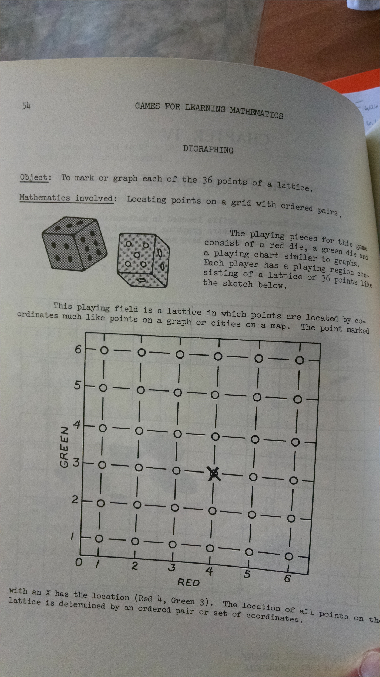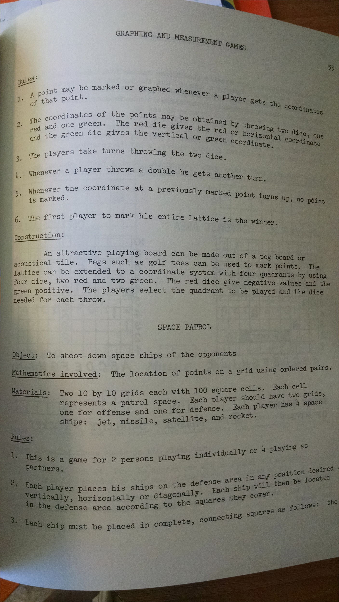

Euler Paths and Circuits
Objective: Students will problem solve to discover Euler paths and circuits from given graphs. 6.1.1.1 Plot pairs of positive rational numbers on a coordinate grid.

Launch: Review graphs, vertices, and edges. Introduce to the class a Vertex Edge Graph. Be sure to identify vertices and edges as this will be a little different from what they work with yesterday. Introduce the idea of an Euler Path. Go through an example (#1 and 2 from worksheet) together to be sure the idea is established. (Allow students to work with their groups on examples given on the worksheet)

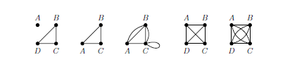

Following students working on paths, present the problem of a circuit. Allow groups to work on the same problems again looking for circuits.

Explore: Students will work through examples looking for Euler paths with their groups. After meeting together, students will work through their examples finding Euler circuits. For groups that finish, have them try to find a reason for why it works or why it doesn’t work.

Share: Go through each example and have different groups share their decisions for each whether it is a path, circuit, or both. See if any group had enough time to find a reason for why or why not.

Summarize: Discuss with students their findings and explain any misconceptions they may have about paths and circuits.

Hamilton Paths and Circuits

Objective: Students will problem solve to discover Hamilton paths and circuits from given graphs. 6.1.1.1 Plot pairs of positive rational numbers on a coordinate grid.

Launch: Review Euler paths and circuits. Introduce the idea of a Hamilton Path. Go through an example (#1 and 2 from worksheet) together to be sure the idea is established. (Allow students to work with their groups on examples given on the worksheet)

Following students working on paths, present the problem of a circuit. Allow groups to work on the same problems again looking for circuits.

Explore: Students will work through examples looking for Hamilton paths with their groups. After meeting together, students will work through their examples finding Hamilton circuits. For groups that finish, have them try to find a reason for why it works or why it doesn’t work.

*Extension: Go to tennis courts to establish if the court creates an Euler path/circuit and/or Hamilton path/circuit

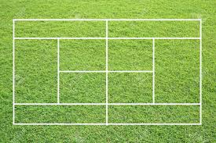

Share: Go through each example and have different groups share their decisions for each whether it is a path, circuit, or both. See if any group had enough time to find a reason for why or why not.

Summarize: Discuss with students their findings and explain any misconceptions they may have about paths and circuits.
Weighted Edge Graphs

Objective: 6.3.1.3 Estimate the perimeter and area of irregular figures on a grid when they cannot be decomposed into common figures and use correct units, such as cm and cm2.

Launch: Review Euler and Hamilton paths and circuits. Introduce a Weighted Edge Graph, be sure to point out the values and that they do not necessarily have to be labeled with units. Challenge students to find the shortest path while hitting all vertices.

Explore: Allow students to work with partners to find the shortest possible path to hit all vertices. Have students post their shortest path on the whiteboard to keep other pairs interested. Do not have them post their path, just their total distance! After they have found the shortest path possible, have them find the shortest circuit.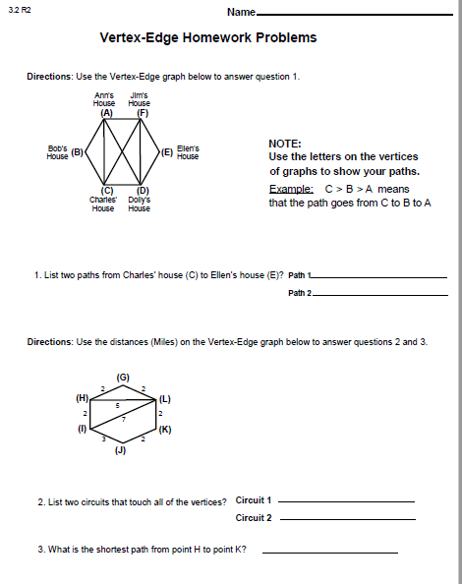

Share: Students share their shortest path and circuit; have them show their path/circuit to the rest of the class on the Smart Board. Students should explain why they made the decisions that they did to find their paths.

Summarize: Review with the class the different ideas pairs had to find the paths they created with their partners.

Greedy Algorithm and Nearest Neighbor

Objective: 6.3.1.3 Estimate the perimeter and area of irregular figures on a grid when they cannot be decomposed into common figures and use correct units, such as cm and cm2

Launch: Review the paths students took yesterday with their partners and how far they had to go for their paths. Introduce the Greedy Algorithm and have students test out the algorithm with their partners on the graph used yesterday. Once students have the Greedy Algorithm, have them try Nearest Neighbor.

Explore: Partners will use Greedy Algorithm to find that circuit, and then do the same thing for the Nearest Neighbor.
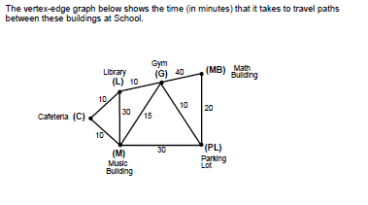

Share: Partners will share their paths they found for each strategy, and why they made the decisions they made. Try to come to a conclusion on which strategy is best when choosing a path.

Summarize: Review the Greedy Algorithm and Nearest Neighbor. Discuss the advantages and disadvantages of each strategy when finding a path. Conclusion...

Organizing Attributes with Venn Diagrams

Objective: Students will be able to classify and organize items into two attribute groups using a Venn Diagram.6.1.3.4 Solve real-world and mathematical problems requiring arithmetic with decimals, fractions and mixed numbers.

Launch: You have a set of Legos and you want to organize them in a way that you can see the different attributes of Legos. Using the Lego Venn Diagram mat (http://lifeovercs.com/classifying-lego-printable-diagrams/) students should take a group of 10-15 Legos and sort them, black Legos in one circle and rectangles in the other.

Explore: Working individually students should try to put their Legos on the mat so that they fit the criteria given. When done we’ll discuss this together and see how the students did. Next the students will be asked to sort the Legos any way they want without telling others. We will walk around the room exploring the different mats and students will record how they think the other students classified their Legos.

Share: Students will share together how they think their classmates organized their Legos and we will see if students are correct.

Summarize: Discuss how Venn Diagrams can be helpful to organize data. How we can see that some of the Legos have multiple attributes. Venn Diagrams can be a way to help us visually see data in a way that lists do not allow.

Assignment: Describing Attributes worksheet (Critical Thinking Activities p. 139)

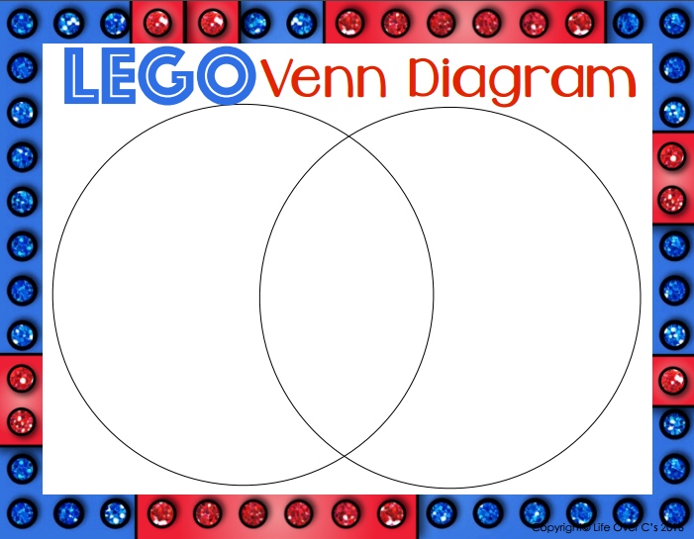

Name: _____________________________________________ Date: _____________
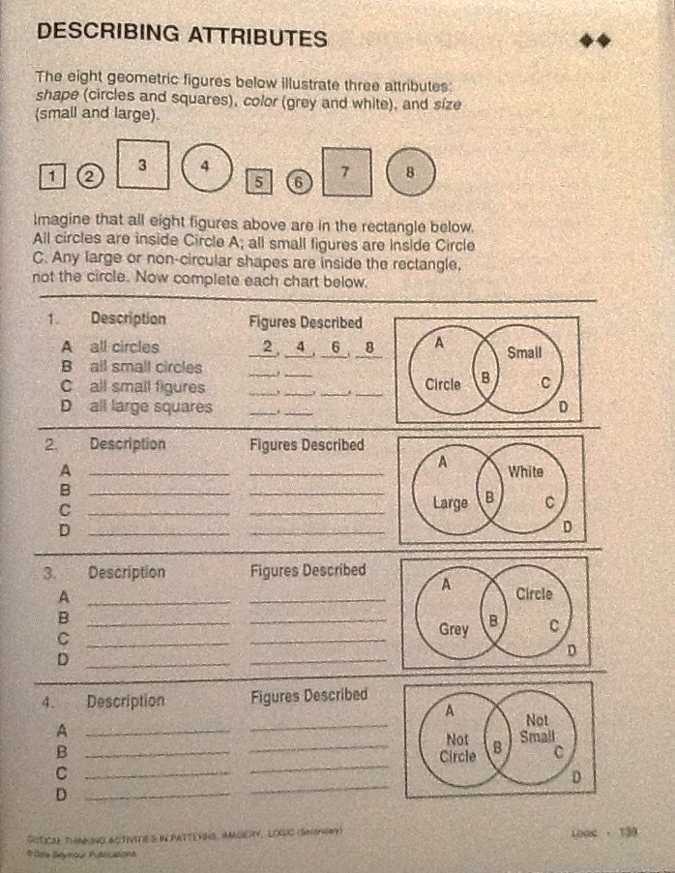

Using Venn Diagrams with Three Circles

Objective: Students will be able to classify and organize items into two attribute groups using a Venn diagram. 6.1.3.4 Solve real-world and mathematical problems requiring arithmetic with decimals, fractions and mixed numbers.

Launch: Review how we used Venn diagrams to organize items into two attribute groups. Pose the questions: Using the Venn diagram below, how do we sort the numbers 1- 25? (Critical Thinking Activities p. 7)

Multiples of 4
Multiples of 3
Multiples of 5

Explore: Give the students time to work with a partner to place all the numbers from 1-25 on the board. Walk around the room guiding students on placement of numbers. Question students about what to do with numbers like 1, 2, 7, etc. When students have completed this portion have the students work with their partner to complete the front of the Venn diagram worksheet (Critical Thinking Activities p. 7)

Share: As a large group, have students come up to put the numbers 1-25 on the large Venn diagram on the whiteboard. Discuss the front side of the worksheet as a large group and answer questions that have come up.

Summarize: When completed discuss why some numbers don’t fit into the circles. Does everything have to fit into a group?

Assignment: Complete the back side of the Venn diagram worksheet

Name: _______________________________________________ Date: __________

Venn Diagram Worksheet

A
B
C
1
9
15
21
8
12
14
6
4
10
2
3
19
13
11
5

- Describe set A. ____________________________________________________
- Describe set B. ____________________________________________________
- Describe set C. ___________________________________________________
- Describe the intersection of sets A and C. _______________________________
- Describe the intersection of sets B and C. _______________________________
- What numbers belong in the intersection of set A and B? ___________________
- What numbers belong in the intersection of sets A and B and C? _____________
________________________________________________________________

Name: ______________________________________________ Date: _____________

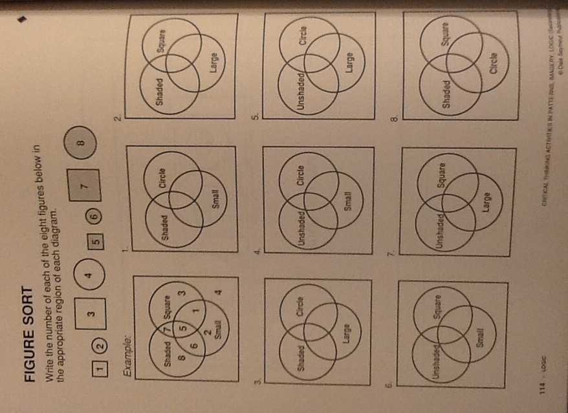

Name: ________________________________________________ Date: __________

Discrete Mathematics Post-Test

- Gabe has three fishing lures (a green one, a yellow one, and an orange) and three types of bait (minnows, worms, & leeches). Create a table to represent the possible fishing combinations.
How many different fishing combinations are there? ________

2. At a restaurant, Erin can choose a choice of seafood, pasta, and beverage. For meat, she can choose salmon or shrimp. She can choose spaghetti, penne, or linguini. She can choose soda or milk. Create a tree diagram to represent the possibilities. Be sure to list the outcomes.
How many possibilities are there? __________________

3. In a dodgeball tournament, how many ways can the four remaining teams be ordered? Make a list to show your arrangements.

4. In how many ways can a group of five friends arrange themselves in a line for a group portrait?

5. Use the data provided from a vote to decide who the winner would be using the Popularity Method, Elimination Method, Borda Method, and Head to Head Method.

Ms. Cook’s class took a vote for where to go on a field trip. They had 4 options: Minnesota Zoo, Valley Fair, Itasca Headwaters, or Movie Theater. Here are their results:

MN Zoo, Valley Fair, Itasca, Movie | 3
Itasca, MN Zoo, Valley Fair, Movie | 2
Movie, MN Zoo, Valley Fair, Itasca | 5
Itasca, Valley Fair, Movie, MN Zoo | 6
Valley Fair, MN Zoo, Movie, Itasca | 4

Which won using the Popularity method? _____________________________________

Which won using the Elimination method? ____________________________________

Which won using the Borda method? _______________________________________

Which won using the Head to Head method? _________________________________

6. Decide if this graph can be used to create an Euler path, Euler circuit, Hamiltonian path, or Hamiltonian circuit.
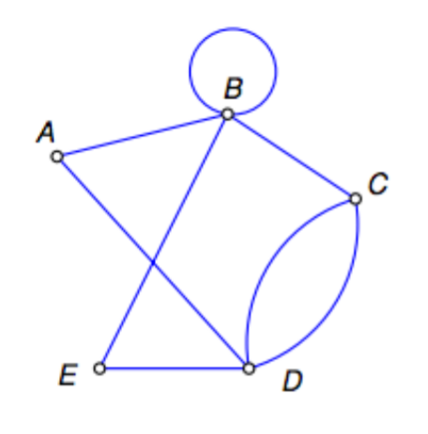

Euler path? ____________ If yes, tell the path: ______________________________________________________________________
Euler Circuit? ____________ If yes, tell the circuit: ______________________________________________________________________
Hamiltonian path? ____________ If yes, tell the path: ______________________________________________________________________
Hamiltonian circuit? ____________ If yes, tell the circuit: ______________________________________________________________________

7.
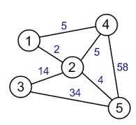
Use the diagram to decide the shortest path possible to start at any location and end at that same location. Do the same thing using the Greedy method and Nearest Neighbor method.

Shortest Path Possible: _____ → _____ → _____ → _____ → _____ = __________

Greedy Method: _____ → _____ → _____ → _____ → _____ = __________

Nearest Neighbor: _____ → _____ → _____ → _____ → _____ = __________

8. Solve the following using a Venn diagram.
In a school of 320 students, 85 students are in the band, 200 students are on sports teams, and 60 students participate in both activities. How many students are involved in either band or sports?

9. Solve the following using a Venn diagram.
A guidance counselor is planning schedules for 30 students. Sixteen students say they want to take French, 16 want to take Spanish, and 11 want to take Latin. Five say they want to take both French and Latin, and of these, 3 wanted to take Spanish as well. Five want only Latin, and 8 want only Spanish. How many students want French only?

